Compound Processing (DLP)

Ohio Department of Medicaid

VUE360RX SPBM Services

Version Number: 1.0

Revision Date: 6/13/2023



Privacy and Security Rules

The Health Insurance Portability and Accountability Act of 1996 (HIPAA – Public Law 104-191) and the HIPAA Privacy Final Rule[1] and the American Recovery and Reinvestment Act (ARRA) of 2009 requires that covered entities protect the privacy and security of individually identifiable health information.

Revision History

|  |  |  |  |
| --- | --- | --- | --- |
| Version # | Published/ Revised | Author | Section/Nature of Change |
| 0.1 | 06/13/2023 | Rachel Carpenter |  |
|  |  |  |  |

Contents

1. Overview 1

2. Purpose 2

3. Multi-Ingredient Compounds 3

3.1 Not Covered 3

3.1.1 Not Medically Necessary 3

4. Prior Authorization Form 4

5. Process 5

6. Approval/Denial 8

# Overview

1. Drug compounding is often regarded as the process of combining, mixing, or altering ingredients to create a medication tailored to the needs of an individual patient. Compounding includes the combining of two or more drugs.
2. Multi-ingredient Compound – a product containing two or more ingredients that is not FDA approved and is prepared upon the order of a prescriber for a patient.
3. Compounded drugs are not FDA-approved. This means that FDA does not verify the safety or effectiveness of compounded drugs. Consumers and health professionals rely on the drug approval process for verification of safety, effectiveness, and quality. Compounded drugs also lack an FDA finding of manufacturing quality before such drugs are marketed.
   1. <https://www.fda.gov/>
4. Compounds must be submitted using each national drug code (NDC) that is a part of the compound. Specific drug products and bulk ingredients utilized in compounds that are not covered will require prior authorization.
5. If a prior authorization is not approved or if a component drug is not eligible for authorization (e.g., manufacturers not participating in the federal Medicaid rebate program), the pharmacy provider may elect to receive payment only for those items in the compound that are directly reimbursed by ODM. These rejected claims can be processed by:
   1. Submitting the claim with the Submission Clarification Code (SCC) (NCPDP field #42Ø-DK) of ‘08’. Note: SCC of 08 should not be utilized for claims that reject for reasons other than product coverage (such as refill too soon, duplicates, etc.) The use of SCC 08 will result in no reimbursement for the noncovered product.
6. Payable active pharmaceutical compounding ingredients and excipients can be located at: https://spbm.medicaid.ohio.gov under “Reference Material”, then “Unified Preferred Drug List”. All compound claims should be submitted with a compound code (NCPDP field #4Ø6-D6) = 2.
   1. [SPBM Pharmacy Reference Guide.pdf (ohio.gov)](https://spbm.medicaid.ohio.gov/SPDocumentLibrary/DocumentLibrary/User%20Guides/SPBM%20Pharmacy%20Reference%20Guide.pdf)

# Purpose

To provide guidance in the prior authorization review and decision process for compound requests.

# Multi-Ingredient Compounds

Multi-ingredient compounds will be considered medically necessary when all the following criteria are met:

1. The active ingredients are prescribed in therapeutic amounts based on FDA approved indications and

2. If a compound is similar to a commercially available product but differs in dosage, dosage form, or inert ingredient, chart notes are required from the prescriber supporting the need for the

compound (i.e., documented difficulty or inability to swallow oral dosage forms, documented

allergies to inactive ingredients) and

3. If any ingredient in the compound, active or inactive, otherwise requires prior authorization, the member must meet criteria established for medical necessity for that ingredient and

4. The member has tried and failed a 30-day trial with all preferred medications that can be used to treat the member’s condition.

## Not Covered

Compounds will not be covered under the following circumstances or as referenced in OAC 5160-9-03:

1. The compound is being used for obesity, sexual dysfunction, infertility, investigational or

experimental use or

2. The compound is for a product that is commercially available or

3. The compound is for convenience purposes only

### Not Medically Necessary

The following compounded preparations are not considered medically necessary as they have not been proven to be more effective than commercially available products:

1. Compounded implantable hormone replacement pellets or granules (such as: estrogen-based

implantable pellets)

2. Bioidentical hormones

3. Topical compounds containing baclofen, gabapentin, and ketamine

# Prior Authorization Form

The following PA Form must be submitted when requesting a compound.

[ODM10184 Prior Authorization Compounds.pdf (ohio.gov)](https://spbm.medicaid.ohio.gov/SPDocumentLibrary/DocumentLibrary/Forms/Compound%20PA%20Fillable%20Form.pdf)

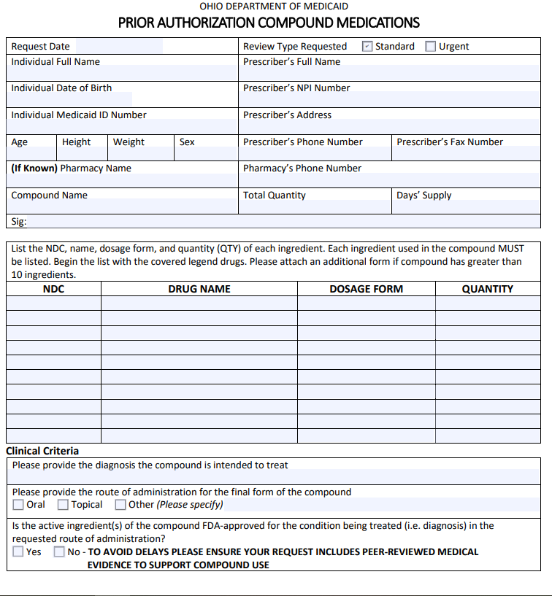

# Process

##### Utilize the OHUPDL-Covered Active Pharmaceutical Ingredients and Excipients for Compounding when reviewing each ingredient for approval or denial

[20221209_Payable_Active_Pharmaceutical_Ingredients_and_Excipients_for_Compounding.pdf (ohio.gov)](https://pharmacy.medicaid.ohio.gov/sites/default/files/20221209_Payable_Active_Pharmaceutical_Ingredients_and_Excipients_for_Compounding.pdf#overlay-context=drug-coverage)

* Review Ingredients/Excipients on NDC Maintenance Tile in Vue360RX for preferred/nonpreferred/payable status

1. Compounds that are less than $100 do not require a PA for cost,
   1. The compound may contain non-preferred products, each claim, PA request must be reviewed and decisioned appropriately. Utilize references available: Lexi, Medical Necessity Policy, OHUPDL and NDC Maintenance Tile in Vue360RX.
2. All compounds that require a PA must be submitted on the Prior Authorization form for Compounds with all ingredients accounted for in the claim to be covered.
3. Technicians will process compound PAs with the active ingredient as one prior authorization to be processed.
4. All steps prior to researching the Compound PA must be completed (information verification).
5. Additional information to be considered (Refer to Medical Necessity Policy)

* **Multi-Ingredient Compounds**

Multi-ingredient compounds will be considered medically necessary when all the following criteria are met:

1.The active ingredients are prescribed in therapeutic amounts based on FDA approved indications and

2. If a compound is similar to a commercially available product but differs in dosage, dosage form, or inert ingredient, chart notes are required from the prescriber supporting the need for the compound (i.e., documented difficulty or inability to swallow oral dosage forms, documented allergies to inactive ingredients) and

3. If any ingredient in the compound, active or inactive, otherwise requires prior authorization, the member must meet criteria established for medical necessity for that ingredient and

4. The member has tried and failed a 30-day trial with all preferred medications that can be used to treat the member’s condition.

* **Compounds will not be covered under the following circumstances or as referenced in OAC 5160-9-03:**

1. The compound is being used for obesity, sexual dysfunction, infertility, investigational or experimental use or

2. The compound is for a product that is commercially available or

3. The compound is for convenience purposes only

* **The following compounded preparations are not considered medically necessary as they have not been proven to be more effective than commercially available products:**

1. Compounded implantable hormone replacement pellets or granules (i.e., estrogen-based implantable pellets)

2. Bioidentical hormones

3. Topical compounds containing baclofen, gabapentin, and ketamine

1. Cost consideration: Review ***Actual Ingredient Cost*** in the claim window:

The following rejection appears if cost is over $100:



This EO would need to be entered when approved.

1. When approving each PA or EO, each must have a daily dose unit for the entire compound being processed to get a successful claim, not the individual ingredients themselves.

For an example omeprazole capsules: Even though only using 60 capsules to make the compound, the daily dose units of the omeprazole capsules in this case would need to be 600/30 to get 20 for the daily dosage units.

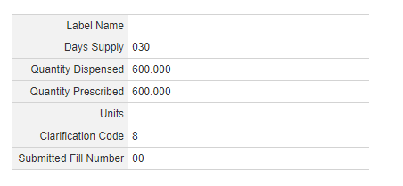

1. All edit overrides will need to be reviewed and addressed per claim rejections: such as: quantity, age, days’ supply
2. If a compound would use a non-payable product (such as: bulk, base, dye, flavoring, or preservatives), a PA and EO should NOT be approved for this but a clarification code of “08” in drug information section to opt out of requesting a payment for a non-payable drug. This will allow the claim to process but not pay for the non-payable ingredients.

For questions on a compounding formula, please use Compounding Formulas (nationwidechildrens.org), it has a list of common basic formulas that are frequently requested, as well as Medication Routes of Administration - StatPearls - NCBI Bookshelf (nih.gov). It is the burden of the prescriber to provide sufficient evidence that a medication fits all the guidance and criteria for compounded medications and ingredients.

# Approval/Denial

* PA requests for a compound of an otherwise commercially available product should not be approved
  + Commercially Available: a marketed drug product and neither has been discontinued nor appears on the FDA drug shortage list under the Section 506E of the Federal Food, Drug, and Cosmetic Act.
  + Commercially available products (commonly requested as compounds):
    - Baclofen Suspension: Fleqsuvy and Baclofen 25mg/5ml
    - Baclofen Solution: Ozobax and Baclofen 5mg/5ml
    - Vancomycin Solution Reconstituted: Firvanq and Vancomycin Solution
    - Zonisade Suspension: Zonisade 100mg/5ml oral susp
* **Medical Necessity considerations for approvals:**
  + Patients with feeding tubes: 3 types: gastrostomy (G), gastrojejunal (GJ), and jejunostomy (J) tubes.
  + Oral aversions
  + Swallowing Issues
  + Developmental disability: such as Autism
  + Pediatric patients
* **Initial Approval:**
* General guidance: Review diagnosis and OHUPDL, approve for 3 months or request on the PA if shorter than 3 months
* **Reauthorization:** 365 days:
  + Must provide documentation of patient’s clinical response to treatment and ongoing safety monitoring
  + Consideration of continuation of therapy should be given for member’s who have previously been on the compounded medication

**Denial:**

* **Denial Language: Medical Necessity Policy - Multi-Ingredient Compounds**

Your request for MULTI-INGREDIENT COMPOUND cannot be approved and is denied because the information provided (including chart notes to support need for therapy) does not meet the following medical necessity coverage requirements:

The active ingredients must be prescribed in therapeutic amounts based on Food and Drug Administration approved indications;

If a compound is similar to a commercially available product but differs in dosage, dosage form, or inert ingredient (such as flavoring, dye, or preservative), clinical documentation is required from the prescriber supporting the need for the compound;

If any ingredient in the compound, active or inactive, otherwise requires prior authorization, you must meet criteria established for medical necessity for that ingredient.

The Gainwell Policy for Medical Necessity was reviewed and per Ohio Administrative Code Rule 5160-1-01 (C) and 5160-26-03 (B), a medically necessary service must include: generally accepted standards of medical practice, be clinically appropriate in administration, treatment & outcome and be the lowest cost alternative to effectively treat the condition. Please contact your provider to assist you with other treatment options that might be covered under your benefit package, or other services that might be available through the community.

**Denial Language: Excluded Coverage for Compounded Preparations:**

The coverage request cannot be approved and is denied due to the following:

1. The compound does not contain a federal legend drug covered by the plan

2. The compound is being used for obesity, sexual dysfunction, infertility, investigational or experimental use

3. The compound is for a product that is commercially available

4. The compound is for convenience purposes only

5. The compound is for implantable hormone replacement pellets or granules (such as: estrogen-based implantable pellets)

6. The compound contains one or more of the following ingredients: baclofen, gabapentin, and ketamine

7. The compound is for a bioidentical hormone

The Gainwell Policy for Medical Necessity was reviewed and per Ohio Administrative Code Rule 5160-1-01 (C), 5160-9-03 (E) and 5160-26-03 (B), a medically necessary service must include: generally accepted standards of medical practice, be clinically appropriate in administration, treatment & outcome and be the lowest cost alternative to effectively treat the condition. Please contact your provider to assist you with other treatment options that might be covered under your benefit package, or other services that might be available through the community.

1. 45 CFR Parts 160 and 164, Standards for Privacy of Individually Identifiable Health Information; Final Rule